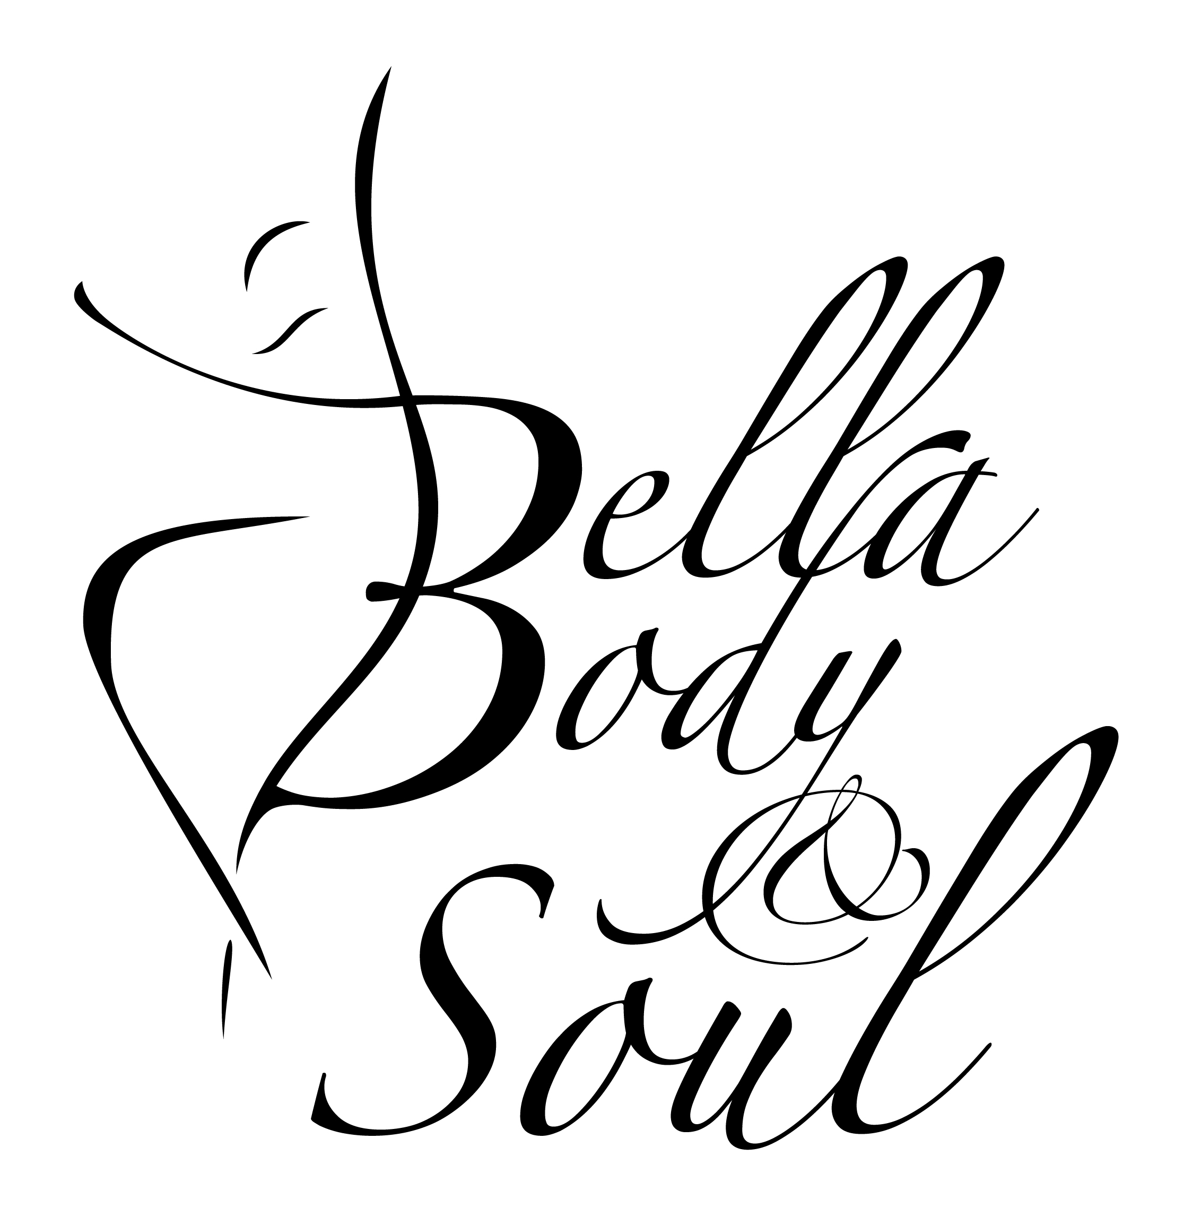
Welcome to Bella Body &Soul…
This booklet is designed to provide information about Bella Body & Soul including terms & conditions. If you have any concerns or require additional information, please do not hesitate to contact me via phone on 0447500436 (no message bank) during office hours Monday to Thursday 10am -2.30pm or email: bellabodyandsoul@gmail.com or face to face or via facebook Bella Body & Soul page or visit website bellabodyandsoul.com
ESSENTIAL CLASS INFORMATION & TERMS & CONDITIONS To ensure maximum participation for all students, we encourage parents to leave children in the care of the dance instructor. To provide adequate dance tuition it is necessary for dance teachers to guide student movement, which may require physical contact. Bella Body & Soul will not be responsible for any injuries or property loss/damage which may occur in class or on the premises. Participants will be required to complete an accident waiver and release of liability form. Medical attention will be sort immediately of needed.
Parents/guardians will be responsible for supervising their children at times prior to commencement of class and after completion of class. Whilst on the premises it is the responsibility of the parents/guardian to ensure the supervision of all children unless they are participating in the class and are under supervision of dance teacher whilst changes classes. Children are not permitted to use play equipment, enter gardens or house or touch any property. Toy box and colouring pencils have been provided and use of the television is allowed. As I collect my own children up from school prior to class, I ask that you do not enter studio until after 3.40pm
Sign in/out register sheets are mandatory and children will not be released without parents/guardians.
Parents and students are required to punctual to class to ensure students do not miss out on the warm up, which is necessary to avoid injury whilst dancing.
Classes are closed to onlookers. Open classes will be advised.
Some classes will continue on Public Holidays and through School Holidays. This will be advised if applicable.
This is a small business all parents/students are required to abide by the fee’s policy and pricing, terms & conditions set out. Payments are to be made by term upfront (no weekly payments )on arrival prior to commencement of Fist class of each term and NO REFUNDS on any payments or students missed classes. Envelopes are provided for fee payment and to be handed to teacher prior to class commencement
Please do not leave payment in the envelope box give any payment to the teacher at commencement of class.
During the period of participation at Bella Body & Soul it is the responsibility of the student/guardian to advise Bella Body & Soul of any personal circumstances and information.
Bella Body & Soul is a SMOKE FREE environment NO Smoking is permitted on premisis.
Emergency/Evacuation meeting point is at the double gates.
WHAT IS EXPECTED: We expect all our students and parents to conduct themselves appropriately when using electronic communication to share information with other members or posting material on public websites connected to the BB&S Dance studio.
ELECTRONIC COMMUNICATION
Should respect and maintain the privacy of all BB&S Dance Studio members & must not be misleading, false or injure the reputation of another person. Should not offend, intimidate, humiliate or bully another person.
Should be restricted to the BB&S Dance Studio matters only and must not bring the BB&S into disrepute.
SOCIAL MEDIA POLICY
Bella Body & Soul may use photographs and/or video footage of the dance student for promotional purposes e.g. website, newspapers, events, or shopping centres (please note individuals will not be named unless permission has been granted from student or parent/guardian). Original photographs/videos taken will be held securely at the postal premises of Bella Body & Soul (BB&S).
- Photos and video’s maybe taken in class or at performances to be used for the advertising of the studio. If you object to your child/children being part of these photos’ please let Ms Renee know.
- No personal information about our students or their families will be disclosed.
- BBS treats all social media postings, blogs, status updates as public ‘comment’.
- All postings (written, photos or videos) will be family-friendly and feature positive news, updates and photos from BB&S. Abusive, discriminatory, intimidating or offensive statements will not be tolerated and offensive posts will be removed and those responsible will be blocked from our site.
- No statements will be made that are misleading, false or likely to injure a person’s reputation and No statements are to be made that might bring the studio into disrepute.
NON-COMPLIANCE
Members may face disciplinary action for sending inappropriate electronic communication or posting online content or comments that harass, offend, intimidate or humiliate another member as outlined in our social media policy. Under certain circumstances cyber bullying is a criminal offence that can be reported to the police.
STUDENT CODE OF CONDUCT
- All students should arrive 5 minutes prior to class to avoid disrupting the teacher and other students and to be ready for commencement of class. Use toilet prior to class and keep noise minimal to avoid disruption of other classes that may be running. No playing outside.
- Food to be consumed in waiting room area.
- Students are required to wear the appropriate clothing and shoes to each class in accordance to the uniform requirements. Hair must be neat and tidy preferred hair style bun for girls for classes where possible at BBS Dance Studio otherwise ponytail is acceptable where stated. All hair to be off the face, with no fringes. If student has short hair please attempt to tie back.
- Due to safety reasons, please ensure that all excessive jewellery is removed before each class (with exception of small earrings).
- Students must understand that dance is fun but also has a DISCIPLINE element. To provide adequate dance tuition it is necessary for dance teachers to guide student movement, which may require physical contact. You may receive corrections, the teacher may raise voice over the music directions/corrections, you may be asked to repeat things numerous times and sometimes the teacher may sometimes need to take a firm stance in class to achieve results. This is not the teacher picking on you or disrespecting you. Your teacher striving for results, maximising your potential and sometimes working to a deadline (concerts, exams or eisteddfods). Corrections mean you are being watched and your teacher is optimising your potential.
- Students will not use their mobile phones during class and must be on silent and in their bags. Unless permission si given by instructor
- Students are NOT to attend classes at any other local dance studios as this creates a conflict of interest unless permission has be sought or arrange by Ms Renee (this complies with most other dance school policies) or other studio owner’s permission (workshops and master classes are not included in this rule). Students will not teach any choreography that has been learnt at BB&S to any students who attend other dance studios. All solo’s and groups are property of BB&S. If a student leaves the studio these routines remain the property of BB&S. All students are encouraged to attend workshops during the holidays if they are offered. All students are asked to be polite and courteous to all teachers, parents and fellow students.
- Students should not upload choreography onto any social media (Facebook, Instagram, YouTube etc.) unless permission is given as this is a breach of copyright.
- Disrespectful behaviour will be addressed with parents and if not rectified you will be asked to leave the studio. NO EXCEPTIONS. Bullying and gossiping will not be tolerated at BBS. This also extends to outside the dance. Students who engage in this behaviour may face disciplinary action and may even be asked to leave the school.
- No student is allowed to smoke or consume alcohol whilst on the premises.
PARENTS CODE OF CONDUCT
- Parents agree to pay a yearly NON-REFUNDABLE registration fee of $20 per child. This fee covers administration costs as well as personal insurance for your child while attending classes at BB&S which is a separate insurance to public liability.
- Parents must notify BB&S staff if their child will be not attending a lesson for whatever reason.
- Parents are asked to have their child/children at class at 5 minutes early to ensure children are ready for commencement of class. Please ensure and encourage your child/ren to have used toilet before class and whilst waiting keep noise minimal to avoid disrupting class that may be running. No playing outside.
- Parents are asked to keep conversations with the teacher in between classes minimal. As most classes run back to back it interferes with other children’s paid lesson time. No communication will be answered during teaching time If you need to speak to the teacher please email, sms message, pm via facebook to arrange a time which suits both parties. The schools email address is bellabodyandsoul@gmail.com we will be more than happy to make time for you during office hours.
- Payment of class/classes is to be made at the beginning of term at first lesson. Please put the correct amount an envelope with your child’s name and class/classes to ensure classes run smoothly. Envelopes will be provided on near attendance roll in box labelled envelopes, give to teacher at start of terms first class or commencement of class.
- Parents are asked to encourage their child/children to dance as long as he/she is interested. Please don’t force your child to attend classes if it’s not what they want and feel free to discuss any issues with the teacher.
- Parents need to indicate on the enrolment form if their child/children has an existing injury or medical conditions prior to starting classes at BBS. In some cases you may be asked to obtain medical clearance from your local GP depending on the injury/condition before commencing classes. If they require any asthma puffers, EPI Pen or specific medicines please indicate this on your enrolment form and supply the studio with an action plan if applicable.
- In the unlikely event of an injury requiring treatment by a doctor an ambulance will be called to the studio. Any parent opposed to this should advise on the enrolment form. Every effort will be made to contact the parent if this situation arises.
- Parents must understand that focus of learning dance at BB&S is fun and also requires a DISCIPLINE element. Your child may receive corrections, the teacher may raise voice over the music directions/corrections and physical contact may be required. Your child may be asked to repeat things numerous times and sometimes the teacher may have to take a firm stance in class to achieve results. This is not the teacher picking on your child or disrespecting your child. Your teacher is striving for results to maximise your child’s potential and sometimes may be working to a deadline (performances, concerts, exams or eisteddfod’s).
- Parents are asked to communicate the rules to their child/ren in an age appropriate way and encourage their child/children to follow the rules of the dance studio and be respectful to teachers, other students and other parents at all times. Parents to ensure Terms and Conditions are read to students in accordance to their age and understanding, so the student understands rules and code of conduct.
- Parents are asked to help promote BB&S in a positive way. If you feel there are issues you would like addressed please discuss with the director rather than between other dance parents or the wider community. Most issues can be quickly resolved avoiding any animosity or negative gossip that may or may not hold truth.
- Unless permission is given Parents should not upload choreography onto any social media (Facebook, Instagram, YouTube etc.) as this is a breach of copyright. Documentation must NOT be shared and to be disposed of appropriately to maintain confidentiality. Parents need to check emails, Facebook posts, group chats, messages (if applicable) regularly. Majority of correspondence for BB&S is done via Facebook or email so please ensure you provide your current email address and Facebook Profile name on the registration form. Also please advise the studio if any of your contact details change during the time you attend classes BB&S.
- Members could face disciplinary action for sending inappropriate electronic communication or posting online content or comments that harass, offend, intimidate or humiliate another member as outlined in our social media policy. Under certain circumstances cyber bullying is a criminal offence that can be reported to the police.
- No parent is allowed to smoke on premises or be under the influence of alcohol or drugs. Alcohol may be allowed to be consumed by those aged 18 at functions only when stated.

CODE OF CONDUCT FOR THE DIRECTOR, GUEST TEACHERS & DANCE TEACHERS OF BBS
- All teachers will have a current Working with Children police check/Criminal History Check and encouraged to undertake First Aid training & certification.
- The director will select teaching staff for classes and workshops with the experience, knowledge and/or qualifications required by the levels, styles and technique to be taught. Any student teachers will be trained and supervised to ensure they maintain the high standard expected from the studio.
- The director and individual teachers will ensure that class sizes are appropriate to the levels, styles and technique being taught. Students will be placed into a class of according to their age, ability or class availability.
- The director and teachers will adhere to code of confidentiality with information regarding your child/children’s ability, all your personal information and any details of meetings that have taken place for all students and parents.
- All teachers will ensure the dance space is safe for all students and will demonstrate professional attitudes including punctuality reliability and responsible care for students.
- All teachers will strive to communicate the love of dance and provide corrections to improve the students’ ability will encourage and support the individuals within the class situation.

- Teachers will strive to develop self-discipline and self-motivation in the students.
- Teachers will endeavour to recognise physical anomalies in students and advise parents to seek medical advice where necessary and ensure all choreography must be anatomically safe and age appropriate.
- Teachers will strive to recognise any bullying within the studio and inform the Director. Appropriate action will be taken against parties involved. Teachers will discuss disrespectful and negative behaviour with parents and try to correct it before asking a student to leave the studio.
- Teachers will always make time to discuss your child/children’s progress when an interview is requested. Teachers will take responsibility for seeking further knowledge in all aspects of dance

Performances/Showcase/Concerts/Festival/Events
At times we may be performing in events if you do not wish your child/children to participate please let Ms Renee know as they are optional not compulsory. A uniform has been introduced to assist with this however there may be times where costumes may have to be purchased. BBS will endeavour to keep this costing as minimal as possible. All costumes are non-refundable once orders have been placed.
WELCOME TO THE BELLA BODY & SOUL DANCE FAMILY! YOURS IN DANCE MS. RENEE XXX (Director)

